**Human-Wildlife Conflict**

Global human-wildlife conflict (HWC) is a growing and serious threat to conservation efforts, which is exacerbated by growing human populations that create a higher demand for land and infrastructure (Dickman, 2010; Makindi, Mutinda, Olekaikai, Olelebo, Aboud, 2014; Mariki, Svarstad, & Benjaminsen, 2014). Some areas that are substantially impacted by HWC include Africa (Makindi, Mutinda, Olekaikai, Olelebo, Aboud, 2014; Mariki, Svarstad, & Benjaminsen, 2014) and Thailand (van de Water & Matteson, 2018). Furthermore, consequences of HWC can be extreme. Examples include destruction of property and assets, spread of diseases, and death. Farmers are particularly vulnerable to these impacts (Makindi, Mutinda, Olekaikai, Olelebo, Aboud, 2014; van de Water & Matteson, 2018). In order to mitigate these conflicts, local residents use various tactics such as firecrackers, fires, and fencing (Makindi, Mutinda, Olekaikai, Olelebo, Aboud, 2014; Mariki, Svarstad, & Benjaminsen, 2014; van de Water & Matteson, 2018). Sanctioned mitigation methods might include forest restoration, ecotourism, providing water sources to protected habitats, educational initiatives, and patrolling (Makindi, Mutinda, Olekaikai, Olelebo, Aboud, 2014; van de Water & Matteson, 2018).

The approach used for mitigation has substantial implications for its effectiveness (Mariki, Svarstad, & Benjaminsen, 2014). One major factor influencing the efficacy of these methods is the extent to which local residents were involved in the decision-making (Dickman, 2010; Mariki, Svarstad, & Benjaminsen, 2014). For example, when local residents are displaced to accommodate wildlife without any choice, they can become resentful and take measures into their own hands. These measures can include extreme behaviors such as collaborating with poachers (Mariki, Svarstad, & Benjaminsen, 2014), which yields the opposite effect of what was intended via the mitigation strategy.

The relationship between HWC, mitigation strategies, and people’s attitudes and behaviors towards wildlife is highly complex. In fact, this relationship has been found to be mediated by risk perceptions of wildlife (Dickman, 2010), intrinsic values and moral foundations (Lute, Navarrete, Nelson, & Gore, 2016), negative encounters with wildlife (van de Water & Matteson, 2018), benefits associated with ecotourism or other conservation participatory experiences (Alix-Garcia, Sims, Orozco-Olvera, Costica, Fernandez Medina, & Romo Monroy, 2018; Eshoo, Johnson, Duangdala, & Hansel, 2018; van de Water & Matteson, 2018), and socio-economic factors (van de Water & Matteson, 2018).

An example of some of the complexities of these relationships is provided via a case study where local residents were surveyed regarding their conflict with elephants in Thailand (van de Water & Matteson, 2018). One particular finding that was surprising is that positive benefits from elephants was associated with both positive and negative views on coexistence. Since the data from the study was available, I downloaded the data and ran a CHAID decision tree model in SPSS to better understand potential interactions. I included all of the variables from the original study except I created a mutually exclusive variable with four categories by combining the negative experiences and benefits variables (no experiences, positive only, negative only, and both positive and negative). Tolerance of elephant coexistence was included as the dependent variable of interest (refer to Figure 1 in Appendix A).

The exploratory results indicate that having no experience with elephants (positive or negative) is associated with a lower tolerance level. This finding could suggest that those without exposure to elephants are less likely to feel a sense of care for such animals. Perhaps education might be most beneficial for this subpopulation. Those with only negative experiences were most likely to have conditional tolerance, which makes sense since they require mitigation strategies to minimize the conflict. Those with some positive exposure are most tolerant, particularly those with higher incomes. Perhaps ecotourism, participation in conservation efforts, and/or providing resources to protective areas (e.g., water) could be most effective for this subpopulation. Finally, it is interesting that perception of conservation importance was not a significant contributor to the model, which could be due to the high percentage of favorable responses in the sample

When considering HWC in my local area (Illinois), some of the most common types occur with wildlife that are abundant, such as coyote, deer, skunks, opossums, and racoons given their abundant populations in the Illinois region and are not necessarily protected. With that being said, conflicts also arise with Sandhill Cranes, which is a protected bird. These birds migrate through Illinois where they also breed, and they can occasionally cause property damage by attacking reflective surfaces such as windows of homes or vehicles. In addition, they have been known to dig up new lawns to search for grubs, and cause crop damage, especially corn fields that are newly planted (Wildlife Illinois, n.d.). These types of conflicts are very similar to those discussed with elephants and lions where property damage and crop damage are primary causes of the conflict.

As a means to help mitigate these conflicts in Illinois, the Illinois Department of Natural Resources published a wildlife action plan that incorporates objectives such as multi-stakeholder collaboration, minimization of habit loss and fragmentation due to development, integration of wildlife and habitat conservation, increasing water quality, and promoting educational initiatives (Illinois Department of Natural Resources, 2018).  Based on prior research, I would recommend using an approach where people can receive payments for environmental services or ecotourism given that such an approach has resulted in favorable outcomes (Alix-Garcia, Sims, Orozco-Olvera, Costica, Fernandez Medina, & Romo Monroy, 2018; Eshoo, Johnson, Duangdala, & Hansel, 2018; van de Water & Matteson, 2018).

**References**

Alix-Garcia, J. M., Sims, K. R. E., Orozco-Olvera, V. H., Costica, L. E., Fernandez Medina, J. D., & Romo Monroy, S. (2018). Payments for environmental services supported social capital while increasing land management. *Proceedings of the National Academy of Sciences of the United States of America,* *115*(27), 7016–7021. Retrieved on 9/14/19 from <https://www-ncbi-nlm-nih-gov.proxy1.ncu.edu/pmc/articles/PMC6142241/pdf/pnas.201720873.pdf>

Dickman, A. J. (2010). Complexities of Conflict: the importance of considering social factors for effectively resolving human-wildlife conflict. *Animal Conservation,*13, 458-466. doi:10.1111/j.1469-1795.2010.00368.x

Eshoo, P. F., Johnson, A., Duangdala, S., & Hansel, T. (2018). Design, monitoring and evaluation of a direct payments approach for an ecotourism strategy to reduce illegal hunting and trade of wildlife in Lao PDR. *PLOS ONE*, *13*(2), e0186133. Retrieved on 9/14/19 from <https://eds-a-ebscohost-com.proxy1.ncu.edu/eds/pdfviewer/pdfviewer?vid=4&sid=df755291-6fd5-4388-91cc-26bd49e3cab7%40sessionmgr4007>

Illinois Department of Natural Resources (2018). *Conservation: Green cities.* Retrieved on 9/21/19 from <https://www.dnr.illinois.gov/conservation/IWAP/Pages/GreenCities.aspx>

Lute, M. L., Navarrete, C. D., Nelson, M. P., & Gore, M. L. (2016). Moral dimensions of human-wildlife conflict. *Conservation Biology,*30(6), 1200-1211. doi: 10.1111/cobi.12731

Makindi, S., Mutinda, M., Olekaikai, N., Olelebo, W., Aboud, A. (2014). Human-wildlife conflicts: Causes and mitigation measures in Tsavo conservation area, Kenya. *International Journal of Science and Research, 3*(6), 1025-1031. Retrieved on 9/21/19 from <https://www.researchgate.net/publication/273031890_Human-Wildlife_Conflicts_Causes_and_Mitigation_Measures_in_Tsavo_Conservation_Area_Kenya>

Mariki, S. B., Svarstad, H., & Benjaminsen, T. A. (2014). Elephants over the cliff: explaining wildlife killings in Tanzania. *Land Use Policy*, 44, 19-30. doi:10.1016/j.landusepol.2014.10.018

van de Water, A. & Matteson, K. (2018). Human-elephant conflict in western Thailand: Socio-economic drivers and potential mitigation strategies. *PLOS ONE*, *13* (6), 1-14. [*https://doi.org/10.1371/journal.pone.0194736*](https://doi.org/10.1371/journal.pone.0194736)

Wildlife Illinois (n.d.). *Birds: Sandhill crane.* Retrieved on 9/21/19 from <https://www.wildlifeillinois.org/gallery/birds/sandhill-crane/>

**Appendix A**

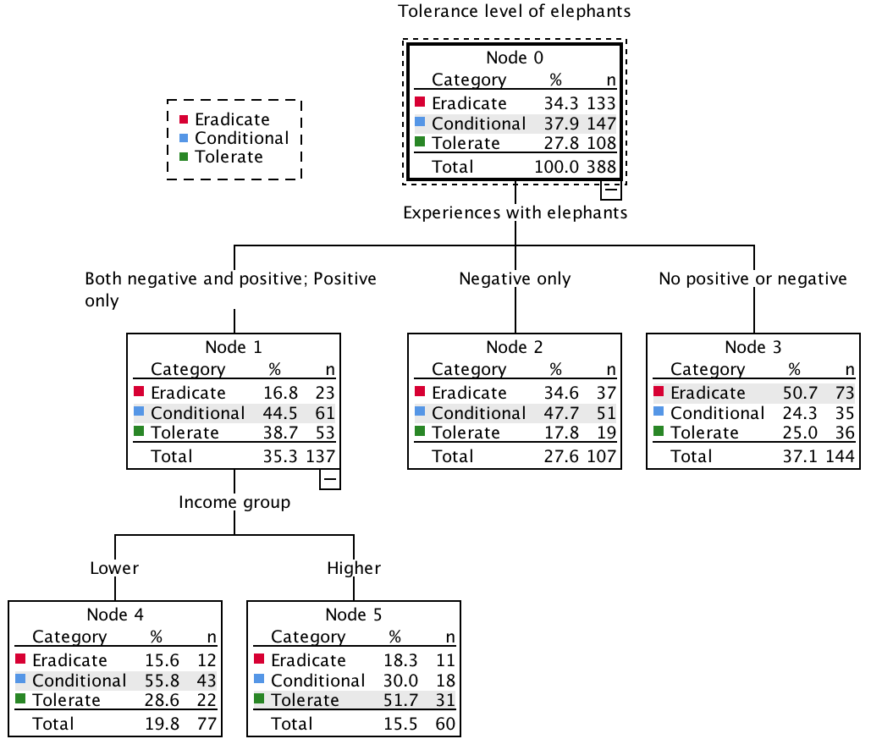

*Figure 1.* Decision tree generated from secondary analysis of van de Water & Matteson (2018) research data with tolerance of elephant coexistence as the dependent variable. These results are purely exploratory and would need to be validated via an independent study.